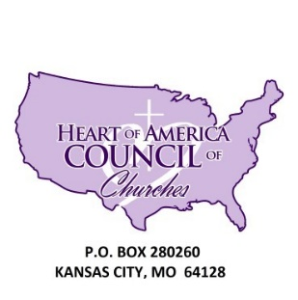

Heart of America Council of Churches
Check Request/Reimbursement Form

Date: ____________________

Reason for Request: FUNDS REQUEST / REIMBURSEMENT (circle one)

Give reason in detail: __________________________________________________________

_____________________________________________________________________________

MAKE CHECK PAYABLE TO: ________________________________________________

Street Address: _______________________________________ Apt #___________

City: _________________________________ State: ______________ Zip: ______________

Amount requested: $ _______________________________

Amount granted: $ _________________________________

Auxiliary President Signature: __________________________________ Date: ___________

Auxiliary Treasurer Signature: __________________________________ Date: ___________

Auxiliary Director Signature: ____________________________________Date: ___________

REQUEST FOR FUNDS POLICY

Before any check can be released to any person or auxiliary this form must be completed, signed, and submitted to the HACC Treasurers Office accompanied by the appropriate receipt(s) or invoice(s). All information on the form must be filled out. All purchases made without prior approval will not be reimbursed. There is no exception to the rule.

Only Bishop Mark C. Tolbert can authorize the release of HACC funds or the person that he has officially designated to release said funds.

